Spot the Difference! Easter Competition

Win a Chocolate Easter Egg and a £15 gift voucher to spend in our Pocket Money Children’s Corner in a game of Spot the Difference.
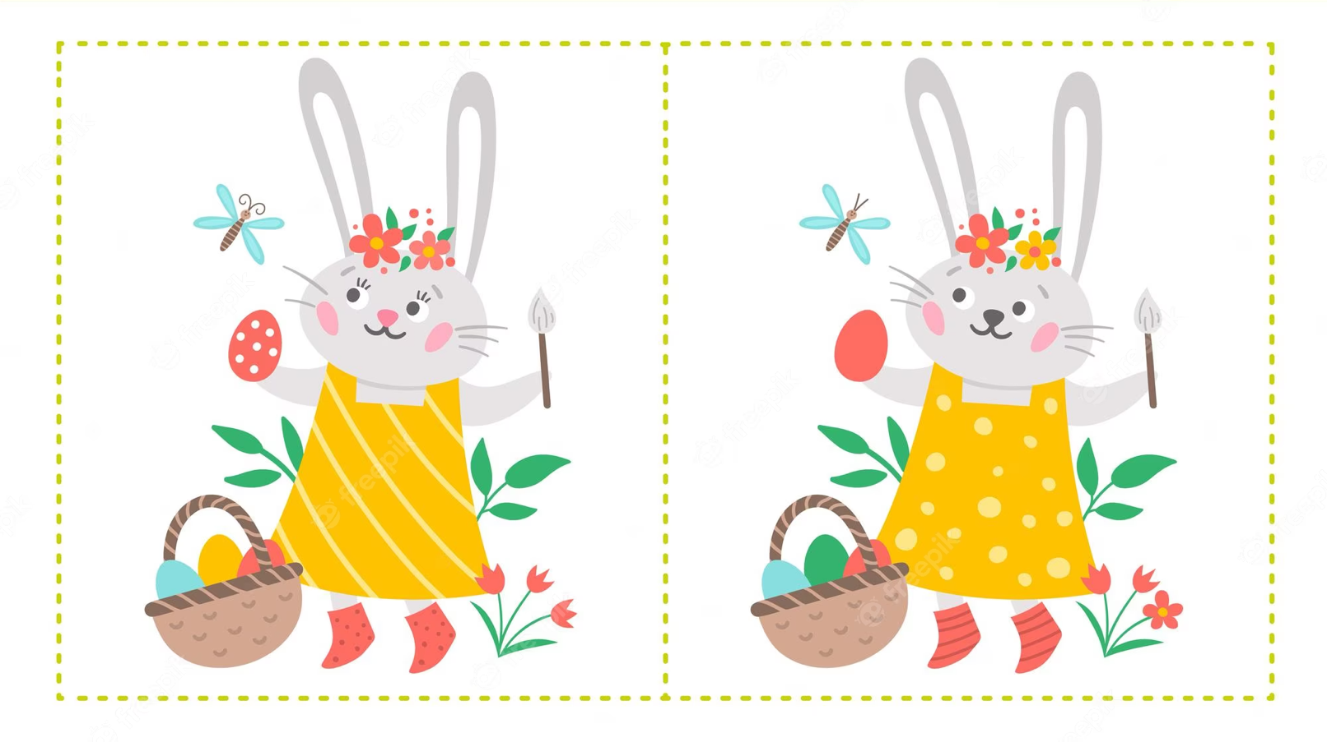
Mrs. Bunny is getting her garden ready for easter! Can you spot 10 differences between the two pictures? Circle them.

Name:

Age:

Contact number:
Don’t let anyone see your answers!
When you think you have found all the differences put this sheet in our entry box at reception.

The competition closes on the 4th April. All correct entries will be put in a box and a winner will be drawn and announced on the 5th April.

