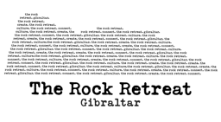
TRUST

‘Memories of the Old Town’
Sketch Safari

Registration Form

FULL NAME: …………………………………………………………………………………

Tel No. …………………………...….

EMAIL ADDRESS: …………………………………………………………………………………

Tick
I wish to participate in the SKETCH SAFARI organised by THE GIBRALTAR HERITAGE TRUST and THE ROCK RETREAT in the OLD TOWN on the 19th MARCH.

I give permission for the GIBRALTAR HERITAGE TRUST
to scan and feature my artwork in a booklet for their Oral History Project ‘MEMORIES OF THE OLD TOWN’.

I understand that I will need to provide my own materials and submit my artwork after the event.

Photo Preference: We sometimes take photos/and or videos during our events.
I give permission for photos/ videos of me to be shared and published for the use of the Trust in the promotion of the event and its results.

Contact details: I consent to the Gibraltar Heritage Trust retaining and using my e-mail address to contact me regarding this project.

SIGNED: …………………………………………….………. DATE: …………………….

