PRESS RELEASE:
GIBRALTAR CITY COUNCIL PIN BADGES

The GHT is pleased to announce the release of a replica of the Gibraltar City Council Pin Badge. This release coincides with the commemorative exhibition to mark the Centenary of the establishment of the Gibraltar City Council in 1921. The exhibition aims to honour and remember the selected or appointed Council Members during their years of service and recognise the many others who supported the Council until its termination in 1969.

The badge itself is modelled off an original badge held by the Gibraltar National Archives and has been adapted for a clutch pin backing.

A limited number of badges have been produced. Badges are on sale at The Gibraltar Heritage Trust shop for just £2.00 or can also be reserved or ordered online via the Trust’s website.

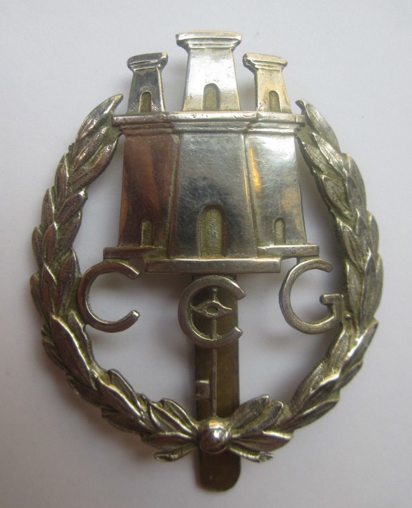

Original City Council Badge Replica City Council Badge

